School Holiday Workshops
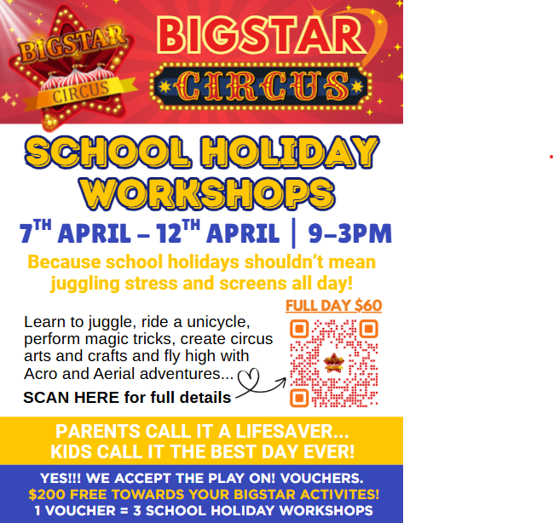

CHANNEL 9 Sent 16.02.26
Hi Petrina,
Rhett suggested I share an exciting story opportunity that we believe many local families would love to hear about - a headline that truly speaks for itself:
“3 FREE Full Days of School Holiday Workshops for Local Kids - Thanks to Play On! Vouchers and BIGSTAR Circus.”
As a not-for-profit foundation, BIGSTAR Circus is committed to making high quality, confidence building activities accessible to everyone in our community. By accepting Play On! Vouchers, eligible families can access $200 in funding - covering up to three full day workshops - giving parents a much needed break while their children enjoy a safe, structured, and inspiring environment during the holidays.
At a time when many parents are looking for alternatives to screens, BIGSTAR Circus offers a refreshing solution. Our full day workshops keep children active, creative, and socially connected through hands-on experiences like bungee and aerial acrobatics, juggling, unicycling, magic, balloon twisting, and circus themed arts and crafts - including props they make themselves to take home. Beyond the fun, children build confidence, resilience, coordination, and friendships in a supportive, non-judgmental space where every child is encouraged to shine.
We see the transformation firsthand - children stepping outside their comfort zones, discovering new strengths, and proudly showing off skills they never imagined possible. Through community events, inclusive NDIS compliant individual or group classes, school holiday workshops, and special events like Kids Night Out, Rhett and the coaching team are creating meaningful impact in the lives of young people across our region. The only missing piece is awareness - more families simply need to know this opportunity exists.
We would love to invite your Channel 9 crew to visit our space, capture the energy of the workshops, and help share this positive community story. I truly believe parents across the Gold Coast would welcome the chance to hear about three free days of engaging school holiday care. Could you please connect me with the appropriate contact to explore this opportunity further?
And Petrina, you’re warmly invited to attend one of our Adult Classes (Aerial, Acro and Circus Skills) on Mondays at 5:45pm. Come along, bring a friend, and experience the magic of BIGSTAR Circus for yourself!
Kind regards,
Jackie
MEDIA RELEASE – News Channels
“This Is a Headline Every Parent Needs to Hear These School Holidays!”
Local Kids Can Access 3 FREE Days of School Holiday Fun - Thanks to Play On! Vouchers and BIGSTAR Circus
Gold Coast families are being offered an exciting opportunity these school holidays, with BIGSTAR Circus Foundation announcing that eligible children can attend up to three full days of workshops at no cost through the Queensland Government’s Play On! Voucher program.
As a not-for-profit organisation dedicated to youth development and community connection, BIGSTAR Circus is focused on making high-quality, confidence-building experiences accessible to all families. The $200 voucher helps remove financial barriers, allowing more children to participate in structured, enriching activities while giving parents a much needed break.
With concerns continuing to grow around excessive screen time, BIGSTAR Circus provides a powerful alternative – full day workshops designed to keep children active, creative, and socially engaged. Participants experience the thrill of bungee and aerial acrobatics, learn skills such as juggling, unicycling, magic, and balloon twisting, and take part in circus themed arts and crafts, even creating their own props to bring home.
Beyond the excitement, the workshops help children develop resilience, coordination, confidence, and friendships in a supportive, non-judgmental environment where every child is encouraged to succeed.
“We see incredible transformations every day,” says Rhett Morrow, founder of BIGSTAR Circus. “Children step outside their comfort zones, discover strengths they didn’t know they had, and leave proud of what they’ve achieved. Our mission is simple - create opportunities for young people to move, connect, and believe in themselves.”
Through inclusive programs, community events, school holiday workshops, and youth focused initiatives, Rhett and the BIGSTAR coaching team continue to make a meaningful impact across the region. The only missing piece is awareness - many families simply don’t realise this opportunity is available to them.
MEDIA OPPORTUNITY:
BIGSTAR Circus invites local news crews to visit the Circus space, capture the colour and energy of the workshops, and share a positive community story that resonates with families across the Gold Coast. Visual moments include children flying through the air on aerial equipment, learning circus skills, laughing with new friends, and building confidence in real time - strong, uplifting footage perfect for broadcast.
We believe parents and caregivers throughout the region would welcome the chance to learn about three free days of engaging school holiday care and the lasting benefits these programs provide.
For media enquiries, interviews, or to arrange a visit, please contact us on admin@bigstarcircus.com or phone Jackie on 0403 873 478.
………………………………
CONTACTS Lusha
ABC Contacts
Corporate media inquiries
Freya Campbell
Director of Communications
campbell.freya@abc.net.au
ABC NEWS media inquiries
Sally Jackson
Communications Lead, ABC NEWS
jackson.sally@abc.net.au
Screen content media inquiries
Nikki Tugwell
Communications Lead, ABC Content
tugwell.nikki@abc.net.au
Audio content media inquiries
Laura Todd
Communications Lead, Audio
todd.laura@abc.net.au
WIN – Channel 9?
Suite 901, Level 9, The Rocket
203 Robina Town Centre Drive
Robina QLD 4230
07 5509 6399
Newsroom Email: nnswnews@winnetwork.com.au

NBN NEWS:
News Enquiries: nbnnews@nine.com.au
General and Sales Enquiries: hsadmin@nine.com.au
GOLD COAST
Newsroom: 02 4099 1645
Sales Enquiries: 07 5509 6399

Channel 7 Email and Online Enquiry Sent and advertising page 16.02.26
If you have a news tip or complaint that is directly related to content on 7NEWS.com.au, including video and photos, you can email us directly - 7ndtips@seven.com.au

Send Us Your Story Tip | Gold Coast Bulletin sent 16.02.26

cos@thecouriermail.com.au sent 16.02.26

MEDIA RELEASE FOR SCHOOLS
3 FREE Full Days of School Holiday Workshops for Local Students — Thanks to Play On! Vouchers and BIGSTAR Circus
BIGSTAR Circus Foundation is proud to offer local families an exciting school holiday opportunity that supports student wellbeing, physical activity, and social connection. Through the Queensland Government’s Play On! Voucher program, eligible families can access $200 in funding — covering up to three full-day school holiday workshops — helping remove financial barriers and ensuring more children can participate in meaningful holiday experiences.
As a not-for-profit organisation, BIGSTAR Circus is dedicated to delivering high-quality, confidence-building programs that are accessible to the entire community. Our structured, full-day workshops provide a safe and inspiring environment where students can stay active and engaged during the holidays while giving parents valuable peace of mind.
At a time when educators and families are increasingly seeking healthy alternatives to screen time, BIGSTAR Circus offers a dynamic solution. Students take part in hands-on activities including bungee and aerial acrobatics, juggling, unicycling, magic, balloon twisting, and circus-themed arts and crafts — even creating their own props to take home. These experiences promote resilience, coordination, creativity, and teamwork while fostering friendships in a supportive, non-judgmental setting where every child is encouraged to thrive.
The impact is evident: children step outside their comfort zones, discover new strengths, and return home proud of what they have achieved. Through community events, inclusive NDIS-friendly individual and group programs, school holiday workshops, and initiatives such as Kids Night Out, Rhett Morrow and the BIGSTAR coaching team continue to make a meaningful difference in the lives of young people across our region.
We invite schools to help share this opportunity with their families so more students can benefit from an active, confidence-building school holiday experience.
Help us support your school community these holidays - because every child deserves the chance to move, connect, and shine.

